**STATE OF SOUTH CAROLINA** )

) **RESOLUTION NO. 11-18**

**NEWBERRY COUNTY** )

**A RESOLUTION AUTHORIZING AN AMENDMENT TO THE MASTER AGREEMENT GOVERNING THE GREENWOOD-NEWBERRY INDUSTRIAL PARK DATED DECEMBER 31, 2012, BETWEEN GREENWOOD COUNTY, SOUTH CAROLINA AND NEWBERRY COUNTY, SOUTH CAROLINA SO AS TO ENLARGE THE BOUNDARIES OF THE PARK; AND OTHER RELATED MATTERS.**

WHEREAS, Newberry County, South Carolina, a political subdivision of the State of South Carolina (“Newberry County”), acting by and through its County Council (the “Newberry County Council”), is authorized pursuant to Article VIII, Section 13(D) of the Constitution of the State of South Carolina and Title 4, Chapter 1 of the Code of Laws of the State of South Carolina 1976, as amended, and specifically Section 4-1-170 thereof (collectively, the “Park Act”), to develop jointly an industrial or business park within the geographical boundaries of one or more counties; and

WHEREAS, pursuant to the Park Act, Newberry County and Lexington County, South Carolina (“Lexington County”) previously entered into that certain Agreement for Development of Joint County Industrial Park dated July 28, 1998 (“Lexington Park Agreement”), whereby they agreed to develop a multi-county industrial/business park including within its boundaries property located in Newberry County and Lexington County (“Lexington Park”), which included within its boundaries several properties located in Newberry County including (1) property owned by Kiswire, Inc., more particularly described on Exhibit B (“Kiswire Property”), (2) property owned by Komatsu America International Company, more particularly described on Exhibit C (“Komatsu Property”), (3) property owned by Pioneer Frozen Foods South Carolina, Inc., more particularly described on Exhibit D (“Pioneer Property”), and (4) property owned by Valmont Composite Structures, Inc., or its related entities, more particularly described on Exhibit E (“Valmont Property,” together with the Kiswire Property, the Komatsu Property, and the Pioneer Property, the “Properties”); and

WHEREAS, pursuant to the terms of the Lexington Park Agreement, the Lexington Park Agreement will terminate on July 28, 2019, and, contemporaneously with the termination of the Lexington Park, Newberry County desires to add the Properties to the Greenwood Park (as defined below);

WHEREAS, also pursuant to the Park Act, Newberry County and Greenwood County previously entered into that certain Master Agreement Governing the Newberry-Greenwood Industrial Park dated December 31, 2012 (the “Greenwood Park Agreement”), whereby they agreed to develop a multi-county industrial/business park including within its boundaries property located in Newberry County and Greenwood County (the “Greenwood Park”); and

WHEREAS, Newberry desires amend the Greenwood Park Agreement as of July 28, 2019, to enlarge the boundaries of the Greenwood Park to include Properties.

WHEREAS, pursuant to Section 1.01 of the Greenwood Park Agreement, Newberry County is authorized to unilaterally increase the Greenwood Park’s boundaries, from time to time by adopting an approving resolution approving such increase in the Greenwood Park’s boundaries; and

NOW, THEREFORE BE IT RESOLVED, by Newberry County Council as follows:

**Section 1. *Expansion of Park Boundaries*.** Upon termination of the Lexington Park Agreement on July 28, 2019, the Properties will immediately transfer from the Lexington Park to the Greenwood Park. Newberry County Council hereby approves the amendment of the Greenwood Park Agreement, and specifically Exhibit A-2 thereto, effective as of July 28, 2019, to enlarge the boundaries of the Greenwood Park to include the Properties. The boundaries of the Greenwood Park will be increased to include the Properties upon adoption of this Resolution by the Newberry County Council and delivery of this Resolution to Greenwood County, to be effective as of July 28, 2019.

**Section 2. *Further Actions***. The Chair of County Council, the County Administrator and the Clerk to County Council, for and on behalf of the County, are hereby each authorized and directed to do any and all things necessary to effect the performance of all obligations of the County under this Resolution.

**Section 3. *Governing Law*.** This Resolution shall be construed and interpreted in accordance with the laws of the State.

**Section 4. *Severability***. The provisions of this Resolution are hereby declared to be separable and if any section, phrase or provision shall for any reason be declared by a court of competent jurisdiction to be invalid or unenforceable, such declaration shall not affect the validity of the remainder of the sections, phrases and provisions hereunder.

[Signature Page Follows

Remainder Intentionally Left Blank]

Adopted in meeting duly assembled this 7th day of November, 2018.

**NEWBERRY COUNTY COUNCIL**

Henry H. Livingston, III Chairman

Newberry County, South Carolina

**ATTEST**

Clerk to Council

Newberry County, South Carolina

**Exhibit a**

**Kiswire Property**

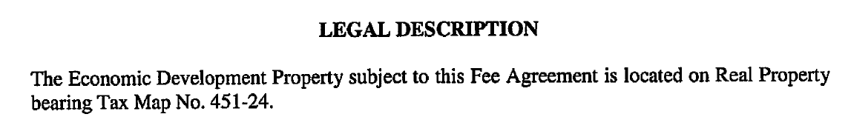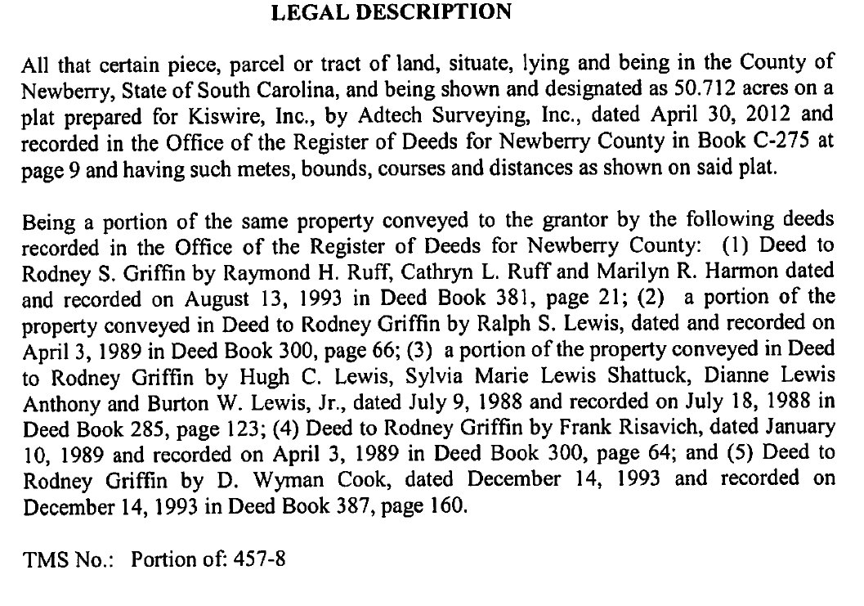

**Exhibit B**

**Komatsu Property**

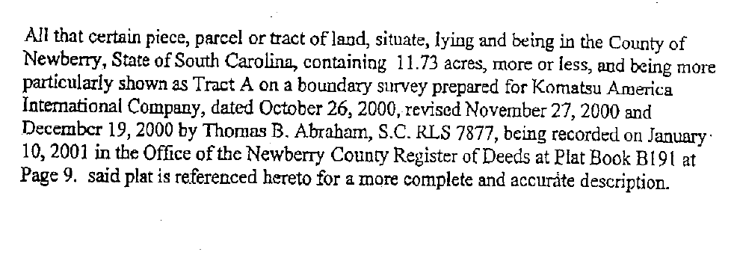

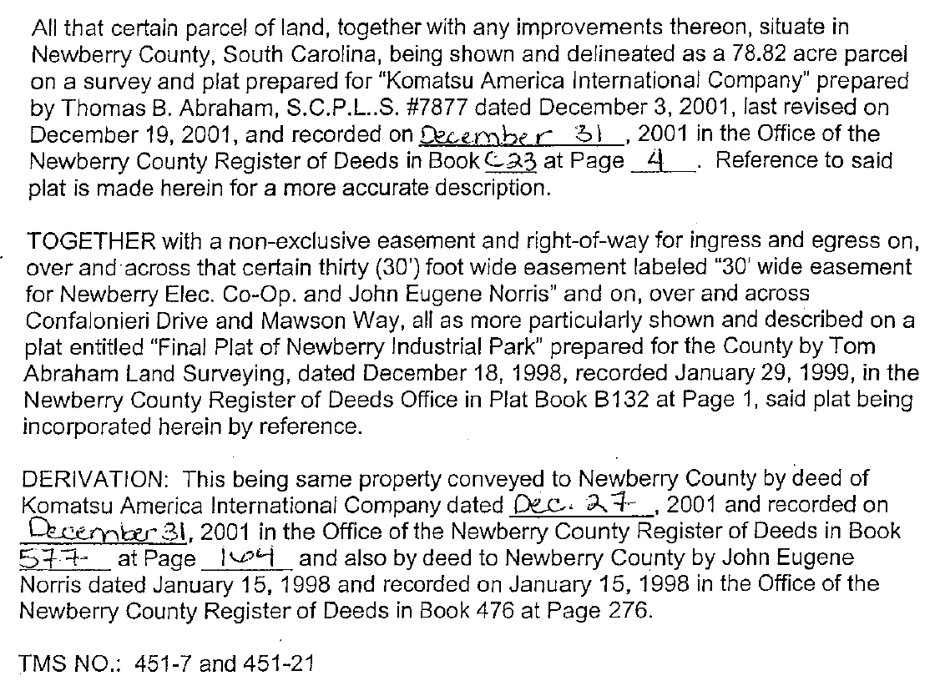

**Exhibit C**

**Pioneer Property**

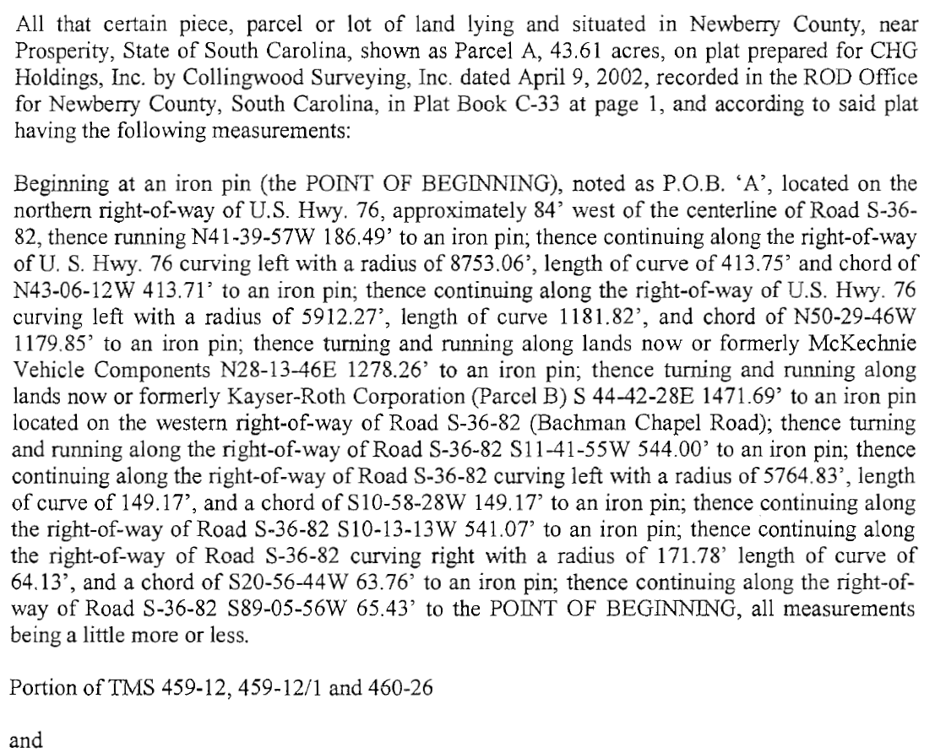

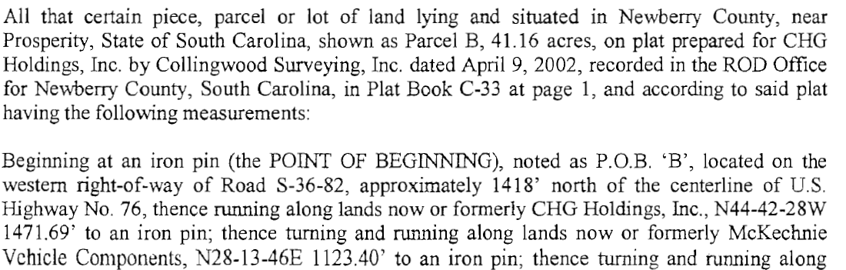

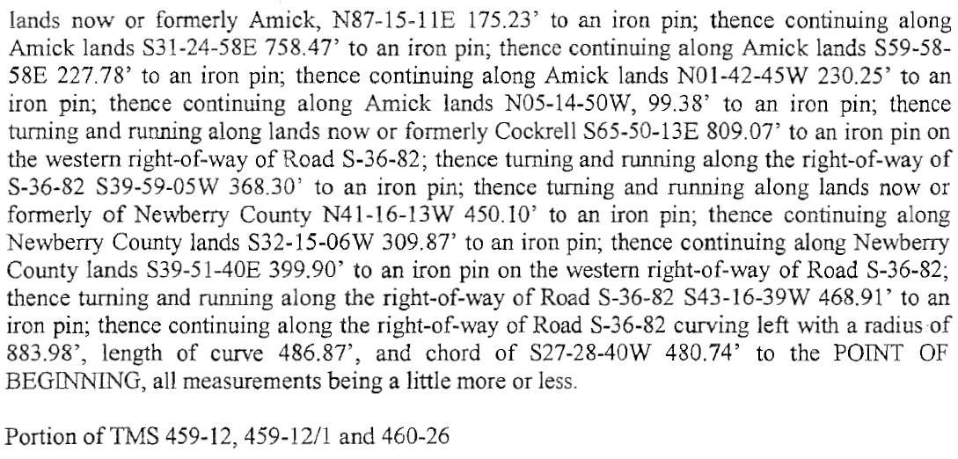 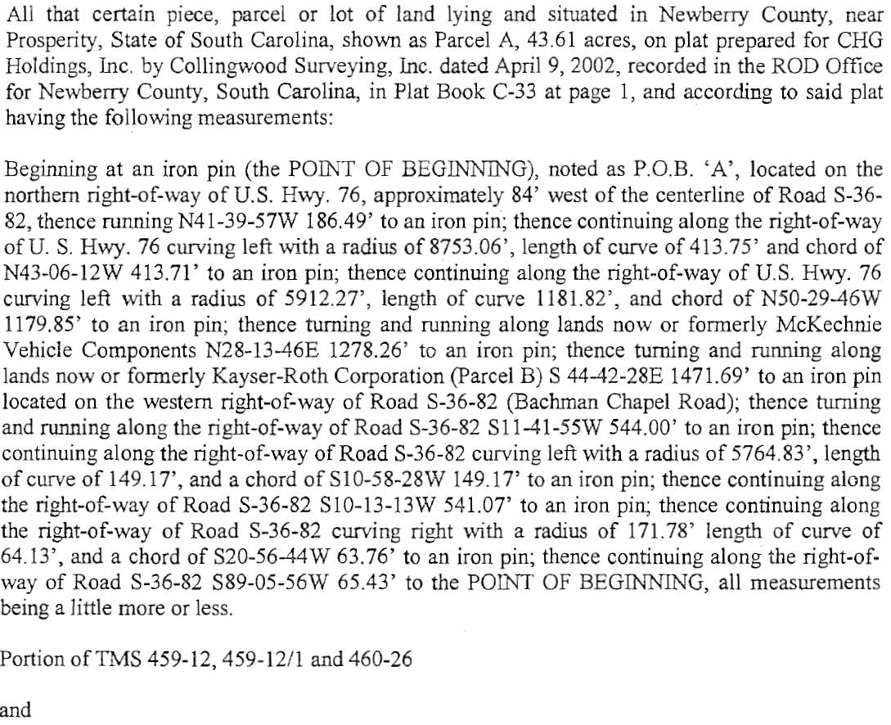

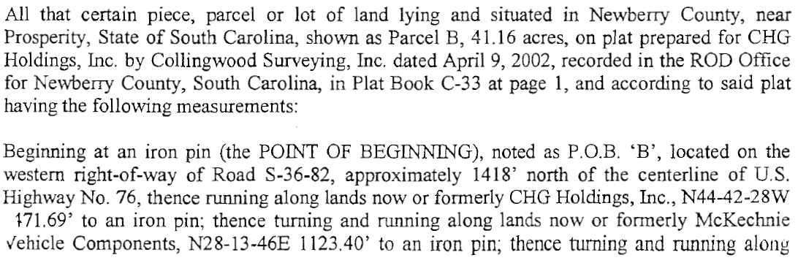 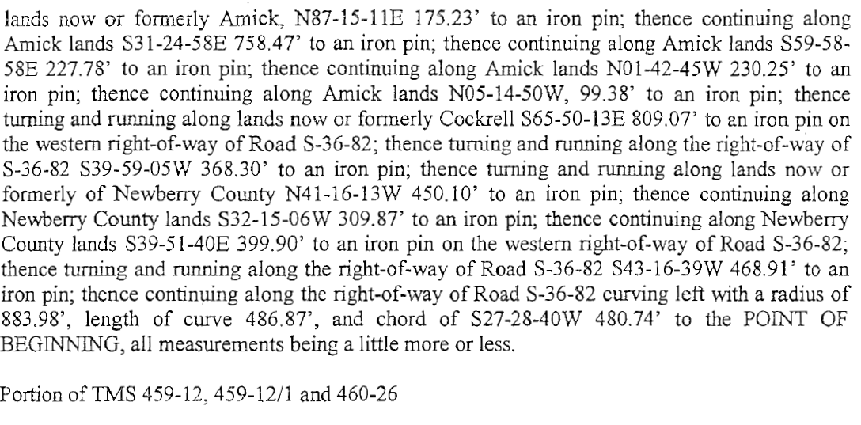

**Exhibit D**

**Valmont Property**

