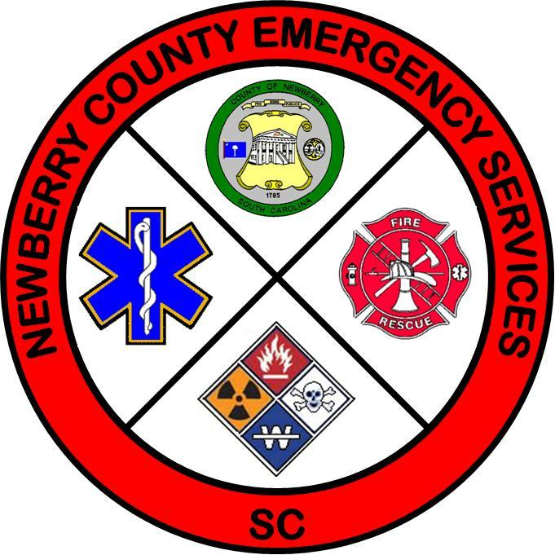

**Newberry County Board of Rescue Squads**

**Regular Meeting**

**March 27, 2024**

**6:00 pm**

| **Attendance:** | **Members:** | Johnson – Sta 14 | Russell - Sta 15 |
| --- | --- | --- | --- |
|  |  | Andrews - Sta 16 | Crouch - Sta 17 | | Birochak – Sta 18 |
|  |  |  |  | |  |
|  | **Others:** | Long - EM1 | Barry Richardson | | Allison Fulmer |
|  |  | Dakota Wise | | |  |

**Call to Order:**

The meeting was called to order.

**Approval of Agenda:**

The agenda was approved with the addition of a discussion of a vehicle replacement plan.

**Approval of Minutes of Previous Meetings:**

Minutes of previous meeting were approved as published.

**Personal Appearances:**

None

**Public Comments:**

None

**Business Items:**

**Old Business**

* + - * Ultrasound Training
        + Mr. Bishop not present.
      * Vehicle Replacement Plan
        + Need for replacement was discussed by council.
        + Chair ask for approval to reach out to NCBRFC to discuss formulate a joint plan.

**New Business**

* + - Dispatch Policy - Revised policy presented and discussed.
    - OSHA Proposal Discussion - Mr. Andrews discussed OSHA proposal for rule making.
    - Budget - Discussion held regarding status.

**Discussion from Members**

* Station 16: Requested an update on firearms policy
* Station 17:Asked that EMS director address emergent vs non response.
* Station 18:Notified Board of a fundraising event on lake.

**Executive Session**

* + - * + None needed.

**Adjourn**

Motion made to adjourn passed.

**Future Meetings:**

Regular Meeting – April 24, 2024, 7:00 pm at EOC.

